(Q) What are the advantage of Bootstrap?

A. Bootstrap is a popular fornt-end faramework that provides a set of tools features to help developers create responsive, mobile- first websites quickly and easily.

a- Open-source and free

b- Easy to use

c- saves times

d- Responsive

e- Customizable

f- Cross-browser compatible.

(Q) What is a Bootstrap Container, and how does it work?

A. A Bootstrap container is a fundamental building block of Bootstrap that contains, pads, and aligns your content within a given device or viewport. Container are used to contain, pad ,and (sometimes) center the content within them while containers can be nested most layouts do not require a nested container.

There are three types of container classes available in Bootstrap.

_ Default container (container)

_ Responsive container (along with sm, md, lg, xl, xxl, )

_ Fluid-container(container-fluid)

1. Default-container

The default .container class is used to contain, pad, and align content within a given device or viewport.

Input-

<!DOCTYPE html>

<html lang="en">

<head>

    <meta charset="UTF-8">

    <meta name="viewport" content="width=device-width, initial-scale=1.0">

    <title>Document</title>

    <link href="https://cdn.jsdelivr.net/npm/bootstrap@5.0.2/dist/css/bootstrap.min.css" rel="stylesheet" integrity="sha384-EVSTQN3/azprG1Anm3QDgpJLIm9Nao0Yz1ztcQTwFspd3yD65VohhpuuCOmLASjC" crossorigin="anonymous">

    <script src="https://cdn.jsdelivr.net/npm/bootstrap@5.0.2/dist/js/bootstrap.bundle.min.js" integrity="sha384-MrcW6ZMFYlzcLA8Nl+NtUVF0sA7MsXsP1UyJoMp4YLEuNSfAP+JcXn/tWtIaxVXM" crossorigin="anonymous"></script>

</head>

<body>

  <div class="container">

    <h1>My First Bootstrap Page</h1>

  </div>

</body>

</html>

0utput-



1. Responsive-container

Responsive containers allow you to specify a class that is wide until the specified breakpoint is reached, after which we apply max widths for each of the higher breakpoints.

Input-

<!DOCTYPE html>

<html lang="en">

<head>

    <meta charset="UTF-8">

    <meta name="viewport" content="width=device-width, initial-scale=1.0">

    <title>Document</title>

    <link href="https://cdn.jsdelivr.net/npm/bootstrap@5.0.2/dist/css/bootstrap.min.css" rel="stylesheet" integrity="sha384-EVSTQN3/azprG1Anm3QDgpJLIm9Nao0Yz1ztcQTwFspd3yD65VohhpuuCOmLASjC" crossorigin="anonymous">

    <script src="https://cdn.jsdelivr.net/npm/bootstrap@5.0.2/dist/js/bootstrap.bundle.min.js" integrity="sha384-MrcW6ZMFYlzcLA8Nl+NtUVF0sA7MsXsP1UyJoMp4YLEuNSfAP+JcXn/tWtIaxVXM" crossorigin="anonymous"></script>

</head>

<body>

<div class="container-sm">.container-sm</div>

<div class="container-md">.container-md</div>

<div class="container-lg">.container-lg</div>

<div class="container-xl">.container-xl</div>

<div class="container-xxl">.container-xxl</div>

</body>

</html>

Output-

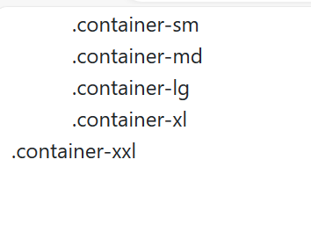

1. Fluid-container

Fluid-container uses the ‘.container-fluid’ class. It is used for a full-width container, spamming the entire width of the viewport.

Input-

<!DOCTYPE html>

<html lang="en">

<head>

    <meta charset="UTF-8">

    <meta name="viewport" content="width=device-width, initial-scale=1.0">

    <title>Document</title>

    <link href="https://cdn.jsdelivr.net/npm/bootstrap@5.0.2/dist/css/bootstrap.min.css" rel="stylesheet" integrity="sha384-EVSTQN3/azprG1Anm3QDgpJLIm9Nao0Yz1ztcQTwFspd3yD65VohhpuuCOmLASjC" crossorigin="anonymous">

    <script src="https://cdn.jsdelivr.net/npm/bootstrap@5.0.2/dist/js/bootstrap.bundle.min.js" integrity="sha384-MrcW6ZMFYlzcLA8Nl+NtUVF0sA7MsXsP1UyJoMp4YLEuNSfAP+JcXn/tWtIaxVXM" crossorigin="anonymous"></script>

</head>

<body>

  <div class="container-fluid">

    <h1>My First Bootstrap Page</h1>

    <p>This is some text.</p>

  </div>

</body>

</html>

0utput-



(Q) What are the default Bootstrap text setting?

(A) Bootstrap provides a set of default text setting that can be customized to suit your needs.

_ font family

_ font size

_ font weight

_ line height

Input-

<!DOCTYPE html>

<html lang="en">

<head>

    <meta charset="UTF-8">

    <meta name="viewport" content="width=device-width, initial-scale=1.0">

    <title>Document</title>

    <link href="https://cdn.jsdelivr.net/npm/bootstrap@5.0.2/dist/css/bootstrap.min.css" rel="stylesheet" integrity="sha384-EVSTQN3/azprG1Anm3QDgpJLIm9Nao0Yz1ztcQTwFspd3yD65VohhpuuCOmLASjC" crossorigin="anonymous">

    <script src="https://cdn.jsdelivr.net/npm/bootstrap@5.0.2/dist/js/bootstrap.bundle.min.js" integrity="sha384-MrcW6ZMFYlzcLA8Nl+NtUVF0sA7MsXsP1UyJoMp4YLEuNSfAP+JcXn/tWtIaxVXM" crossorigin="anonymous"></script>

</head>

<body>

  <div class="container">

    <h1>My First Bootstrap Page</h1>

    <p>This part is inside a .container class.</p>

    <p>The .container class provides a responsive fixed width container.</p>

    <p>Resize the browser window to see that the container width will change at different breakpoints.</p>

  </div>

</body>

</html>

Input-

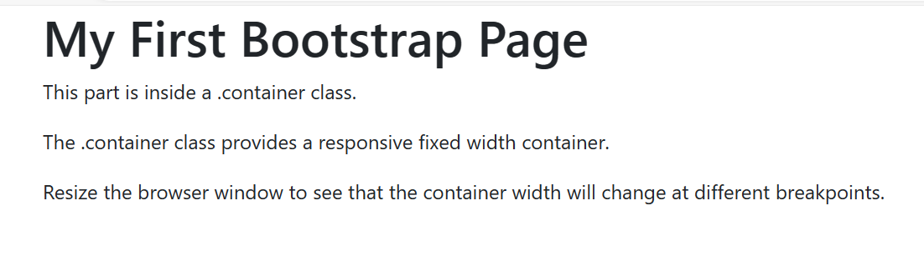

(Q) What do you know about the Bootstrap Grid system?

(A) Bootstrap’s grid system allows up to 12 columns across the page.

Bootstrap’s grid system uses a series of containers. Rows, and column to layout and align content. it’s built with flexbox and is fully responsive.

Example-

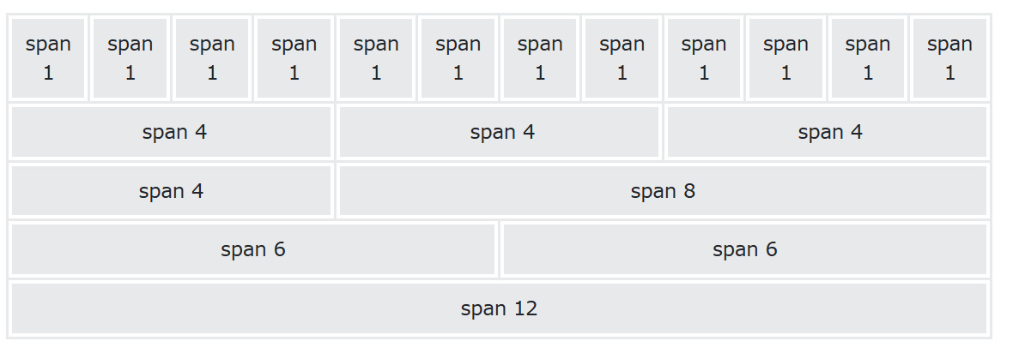

1 – xs (screen less than 768 px wide)

2- sm (screens equal to or greater than 768 wide)

3- md(screens equal or greater than 992 wide)

4- lg (screens equal to or greater than 1200 px wide)

Input-

<!DOCTYPE html>

<html lang="en">

<head>

    <meta charset="UTF-8">

    <meta name="viewport" content="width=device-width, initial-scale=1.0">

    <title>Document</title>

    <link href="https://cdn.jsdelivr.net/npm/bootstrap@5.0.2/dist/css/bootstrap.min.css" rel="stylesheet" integrity="sha384-EVSTQN3/azprG1Anm3QDgpJLIm9Nao0Yz1ztcQTwFspd3yD65VohhpuuCOmLASjC" crossorigin="anonymous">

    <script src="https://cdn.jsdelivr.net/npm/bootstrap@5.0.2/dist/js/bootstrap.bundle.min.js" integrity="sha384-MrcW6ZMFYlzcLA8Nl+NtUVF0sA7MsXsP1UyJoMp4YLEuNSfAP+JcXn/tWtIaxVXM" crossorigin="anonymous"></script>

</head>

<body>

  <div class="row">

    <div class="col-sm-3 p-3 bg-primary text-white">.col</div>

    <div class="col-sm-3 p-3 bg-dark text-white">.col</div>

    <div class="col-sm-3 p-3 bg-primary text-white">.col</div>

    <div class="col-sm-3 p-3 bg-dark text-white">.col</div>

  </div>

  <div class="row mt-3">

    <div class="col-sm-3 p-3 bg-primary text-white">.col</div>

    <div class="col-sm-3 p-3 bg-dark text-white">.col</div>

    <div class="col-sm-3 p-3 bg-primary text-white">.col</div>

    <div class="col-sm-3 p-3 bg-dark text-white">.col</div>

  </div>

</body>

</html>

Output-

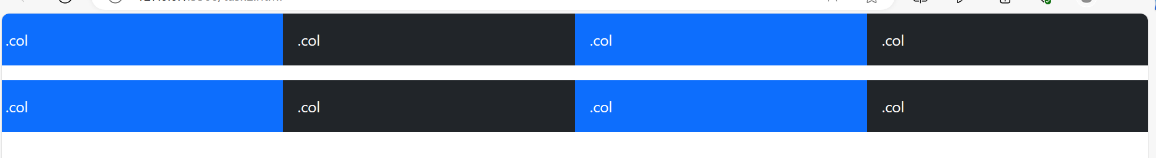

(Q) What is difference between Bootstrap 4 and Bootstrap 5 ?

|  |  |  |
| --- | --- | --- |
| Basic of | Bootstrap 4 | Bootstrap 5 |
| Grid system | it has 5 tier | It has 6 tier |
| color | It has limited color | Extra color added |
| jQuery | It has jQuery and all related plugins | jQuery is removed |
| Internet Explore | Support both IE 10 and 11 | Doesn’t support IE and 11 |
| Form elements | Form uses whatever default provide | Form can be customized and form controls can be added they would not depend on browser |
| Utility API | We can not modify utilities | Modify and also create our own utilities |
| Gutter | Use gutter with font size in px | Use gutter with font size in rem |
| Vertical classes | Columns can be positoned | Columns cannot be positioned relative |
| icon | Doesn’t have its own SVG icons | Its own SVG icons |
| jumbotron | Its supported | Doesn’t supporte |
| Card deck | Card deck card used to create a set of card with equal width and height | Card deck class remove |
| Navbar | We have inline-block property and we will get white dropdown | Inline- block property is removed and we will get black dropdown |
| Static site generator | Uses Jekyll software | Uses Hugo softwere |
| Flexbox grid | Easier to implement vartical designs and the columns and row can be easily be implemented | Advance grid system is made available |
| RTL (Right to left ) Supports | It does not enable Rtl | It enables RTL |
| Off cnavas | It does not support off canvas | It support off canvas |
|  |  |  |

(Q) What is the button Group, and what is the class for a basic Button Group?

A. A button group is a component in Bootstrap that groups a series of buttons together on a single line and superpowers them with JavaScript.

Input-

<!DOCTYPE html>

<html lang="en">

<head>

    <meta charset="UTF-8">

    <meta name="viewport" content="width=device-width, initial-scale=1.0">

    <title>Document</title>

    <link href="https://cdn.jsdelivr.net/npm/bootstrap@5.0.2/dist/css/bootstrap.min.css" rel="stylesheet" integrity="sha384-EVSTQN3/azprG1Anm3QDgpJLIm9Nao0Yz1ztcQTwFspd3yD65VohhpuuCOmLASjC" crossorigin="anonymous">

    <script src="https://cdn.jsdelivr.net/npm/bootstrap@5.0.2/dist/js/bootstrap.bundle.min.js" integrity="sha384-MrcW6ZMFYlzcLA8Nl+NtUVF0sA7MsXsP1UyJoMp4YLEuNSfAP+JcXn/tWtIaxVXM" crossorigin="anonymous"></script>

</head>

<body>

  <div class="btn-group">

    <button type="button" class="btn btn-primary">Apple</button>

    <button type="button" class="btn btn-success">Samsung</button>

    <button type="button" class="btn btn-danger">Sony</button>

  </div>

</body>

</html>

Output-

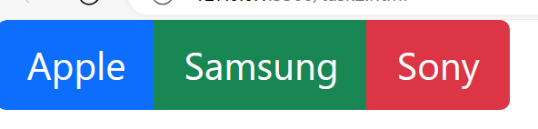

(Q) How can you use Bootstrap to make thumbnails?

A.

Step 1- Include Bootstrap and JQuery CDN into the <head> tag before all other stylesheets to load our CSS.

Step-2 Add <div> tag in the HTML body with the class row in that <div> create four div section to create four images.

Step-3 Add “col-sm-6” and “col-md-3” to four div section which create webpage responsive.

Step-4 Add <a> tag with class value thumbnail to define the link of the image in the next line.

Input-

<!DOCTYPE html>

<html lang="en">

<head>

    <meta charset="UTF-8">

    <meta name="viewport" content="width=device-width, initial-scale=1.0">

    <title>Document</title>

    <link href="https://cdn.jsdelivr.net/npm/bootstrap@5.0.2/dist/css/bootstrap.min.css" rel="stylesheet" integrity="sha384-EVSTQN3/azprG1Anm3QDgpJLIm9Nao0Yz1ztcQTwFspd3yD65VohhpuuCOmLASjC" crossorigin="anonymous">

    <script src="https://cdn.jsdelivr.net/npm/bootstrap@5.0.2/dist/js/bootstrap.bundle.min.js" integrity="sha384-MrcW6ZMFYlzcLA8Nl+NtUVF0sA7MsXsP1UyJoMp4YLEuNSfAP+JcXn/tWtIaxVXM" crossorigin="anonymous"></script>

</head>

<body>

 <div class="row">

  <div class="col-sm-6 col-md-3">

    <a href="" class="thumbnail">

      <img src="https://th.bing.com/th?id=OIP.QIGQqVlSAO4zEfVk4FCSzAHaFj&w=288&h=216&c=8&rs=1&qlt=90&o=6&dpr=1.5&pid=3.1&rm=2" alt="" style="height: 200px; width: 200px;">

    </a>

  </div>

  <div class="col-sm-6 col-md-3">

    <a href="" class="thumbnail">

      <img src="https://th.bing.com/th?id=OIP.QIGQqVlSAO4zEfVk4FCSzAHaFj&w=288&h=216&c=8&rs=1&qlt=90&o=6&dpr=1.5&pid=3.1&rm=2" alt="" style="height: 200px; width: 200px;">

    </a>

  </div>

  <div class="col-sm-6 col-md-3">

    <a href="" class="thumbnail">

      <img src="https://th.bing.com/th?id=OIP.QIGQqVlSAO4zEfVk4FCSzAHaFj&w=288&h=216&c=8&rs=1&qlt=90&o=6&dpr=1.5&pid=3.1&rm=2" alt="" style="height: 200px; width: 200px;">

    </a>

  </div>

  <div class="col-sm-6 col-md-3">

    <a href="" class="thumbnail">

      <img src="https://th.bing.com/th?id=OIP.QIGQqVlSAO4zEfVk4FCSzAHaFj&w=288&h=216&c=8&rs=1&qlt=90&o=6&dpr=1.5&pid=3.1&rm=2" alt="" style="height: 200px; width: 200px;">

    </a>

  </div>

 </div>

</body>

</html>

Output-

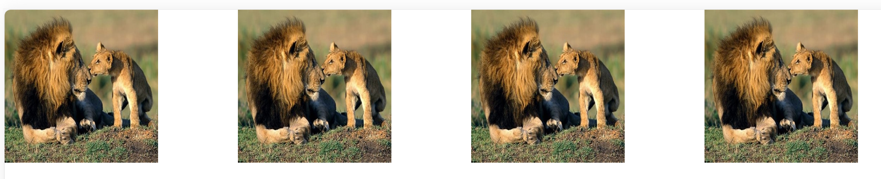

(Q) In Bootstrap 4, what is flexbox?

A. Bootstrap 4 now uses flexbox, instead of floats, to handle the layout. The flexible box layout modules, makes it easier to design flexible responsive layout structure without using float or positioning.

Input –

<!DOCTYPE html>

<html lang="en">

<head>

    <meta charset="UTF-8">

    <meta name="viewport" content="width=device-width, initial-scale=1.0">

    <title>Document</title>

    <link href="https://cdn.jsdelivr.net/npm/bootstrap@5.0.2/dist/css/bootstrap.min.css" rel="stylesheet" integrity="sha384-EVSTQN3/azprG1Anm3QDgpJLIm9Nao0Yz1ztcQTwFspd3yD65VohhpuuCOmLASjC" crossorigin="anonymous">

    <script src="https://cdn.jsdelivr.net/npm/bootstrap@5.0.2/dist/js/bootstrap.bundle.min.js" integrity="sha384-MrcW6ZMFYlzcLA8Nl+NtUVF0sA7MsXsP1UyJoMp4YLEuNSfAP+JcXn/tWtIaxVXM" crossorigin="anonymous"></script>

</head>

<body>

 <div class="container">

  <div class="d-flex justify-content-around text-white">

    <div class="p-3 bg-danger">flex1</div>

    <div class="p-3 bg-info">flex2</div>

    <div class="p-3 bg-success">flex3</div>

  </div>

 </div>

</body>

</html>

Output-

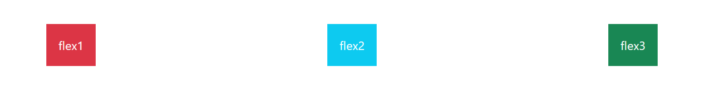

(Q) How can one create an alert in Bootstrap?

A. Bootstrap alerts are used to provide to create predefined alert messages.

Input-<!DOCTYPE html>

<html lang="en">

<head>

    <meta charset="UTF-8">

    <meta name="viewport" content="width=device-width, initial-scale=1.0">

    <title>Document</title>

    <link href="https://cdn.jsdelivr.net/npm/bootstrap@5.0.2/dist/css/bootstrap.min.css" rel="stylesheet" integrity="sha384-EVSTQN3/azprG1Anm3QDgpJLIm9Nao0Yz1ztcQTwFspd3yD65VohhpuuCOmLASjC" crossorigin="anonymous">

    <script src="https://cdn.jsdelivr.net/npm/bootstrap@5.0.2/dist/js/bootstrap.bundle.min.js" integrity="sha384-MrcW6ZMFYlzcLA8Nl+NtUVF0sA7MsXsP1UyJoMp4YLEuNSfAP+JcXn/tWtIaxVXM" crossorigin="anonymous"></script>

</head>

<body>

 <div class="container">

  <div class="alert alert-success">

    <strong>Success!</strong> You should <a href="#" class="alert-link">read this message</a>.

  </div>

  <div class="alert alert-info">

    <strong>Info!</strong> You should <a href="#" class="alert-link">read this message</a>.

  </div>

  <div class="alert alert-warning">

    <strong>Warning!</strong> You should <a href="#" class="alert-link">read this message</a>.

  </div>

  <div class="alert alert-danger">

    <strong>Danger!</strong> You should <a href="#" class="alert-link">read this message</a>.

  </div>

  <div class="alert alert-primary">

    <strong>Primary!</strong> You should <a href="#" class="alert-link">read this message</a>.

  </div>

 </div>

</body>

</html>

Output-

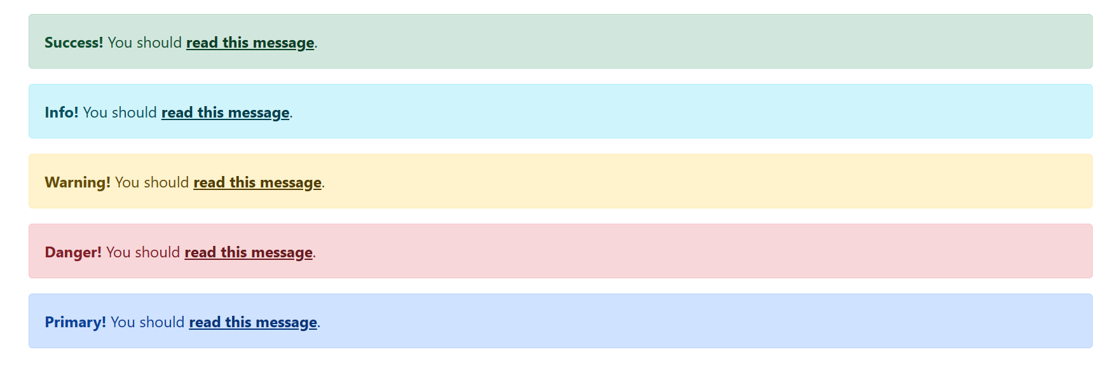

(Q) What is a Bootstrap card and how would you create one?

A. A card is a flexible and extensible content container. It includes options for headers and footers, a wide variety of content, contextual background colors, and powerful display options.

Input-

<!DOCTYPE html>

<html lang="en">

<head>

    <meta charset="UTF-8">

    <meta name="viewport" content="width=device-width, initial-scale=1.0">

    <title>Document</title>

    <link href="https://cdn.jsdelivr.net/npm/bootstrap@5.0.2/dist/css/bootstrap.min.css" rel="stylesheet" integrity="sha384-EVSTQN3/azprG1Anm3QDgpJLIm9Nao0Yz1ztcQTwFspd3yD65VohhpuuCOmLASjC" crossorigin="anonymous">

    <script src="https://cdn.jsdelivr.net/npm/bootstrap@5.0.2/dist/js/bootstrap.bundle.min.js" integrity="sha384-MrcW6ZMFYlzcLA8Nl+NtUVF0sA7MsXsP1UyJoMp4YLEuNSfAP+JcXn/tWtIaxVXM" crossorigin="anonymous"></script>

</head>

<body>

 <div class="container">

  <h1 class="text-center text-primary">Bootstrap cards</h1>

  <div class="card bg-primary text-white">

    <div class="card-body">Primary card</div>

  </div>

  <br>

  <div class="card bg-success text-white">

    <div class="card-body">Success card</div>

  </div>

  <br>

  <div class="card bg-info text-white">

    <div class="card-body">Info card</div>

  </div>

  <br>

  <div class="card bg-warning text-white">

    <div class="card-body">Warning card</div>

  </div>

  <br>

 </div>

</body>

</html>

Output-

